Overview
Big Mountain Resort wants to identify optimal lift ticket pricing strategies that maximize revenue without discouraging customers. By analyzing other U.S. ski resorts’ characteristics and prices, we aim to build a predictive model that determines which factors most influence ticket pricing and use it for scenario modeling and recommendations.

Data Wrangling

The dataset contained information on 300+ ski resorts across North America. Data cleaning steps included:

- Removing missing or inconsistent records for ticket prices and resort attributes.
- Converting numeric columns (e.g., “Runs,” “Lifts,” “Vertical Drop”) to proper datatypes.
- Encoding categorical variables like Region and Night Skiing using one-hot encoding.
- Handling outliers in price and vertical drop using IQR-based filtering.

Exploratory Data Analysis
Numerical features included Runs, Total Chairs, Vertical Drop, Adult Weekend Price, Skiable Area, and Snowmaking %, while categorical features covered Region, State, and Night Skiing.
Engineered metrics like resorts_per_100k_capita, resort_days_open_state_ratio, and total_chairs_skiable_ratio captured resort efficiency and competitiveness.
EDA revealed that Vertical Drop, Runs, and Total Chairs correlated most strongly with price; state-level clustering existed (e.g., CO, UT, VT), but high within-state variation means state should serve as context, not a primary predictor. Outlier resorts with extreme prices were flagged, and future modeling will emphasize engineered ratios and core physical attributes as key predictors.
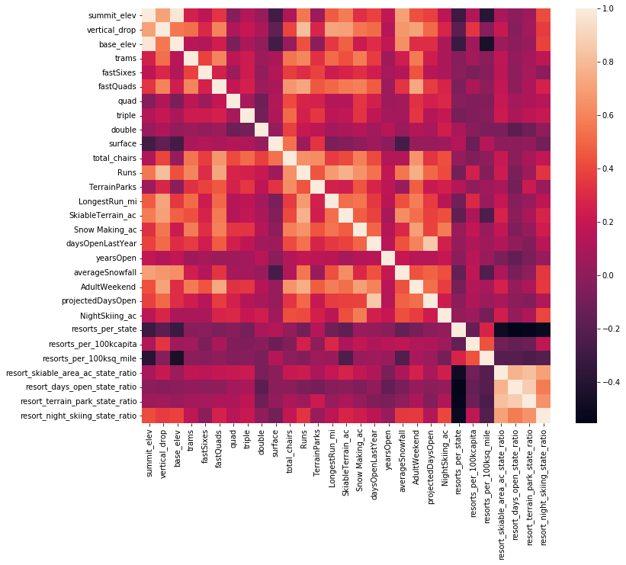
Figure 1 – Correlation heatmap of numerical resort features vs. price
Higher correlations are seen for Vertical Drop, Runs, and Total Chairs, indicating that larger, better-equipped resorts tend to charge higher weekend ticket prices.

Model Preprocessing with Feature Engineering
Categorical fields were one-hot encoded, numerical fields standardized, and engineered ratios like total_chairs_skiable_ratio added to the feature set.

The data was split into 80% training and 20% testing. These preprocessing steps ensured balanced representation across resort types and regions.

Algorithms and Evaluation Metric
Two models were trained and compared:
- Linear Regression (baseline)
- Random Forest Regressor (non-linear benchmark)
Model performance was assessed using Root Mean Squared Error (RMSE).
The Random Forest achieved the lowest RMSE, showing superior predictive accuracy over Linear Regression.

Winning Model and Scenario Modelling
The Random Forest model was selected as the winning model.
Feature importance analysis identified Vertical Drop, Runs, Total Chairs, Region, and Snowmaking % as the top predictors.
Scenario testing showed that improving infrastructure by adding lifts or increasing vertical drop could justify higher pricing tiers.
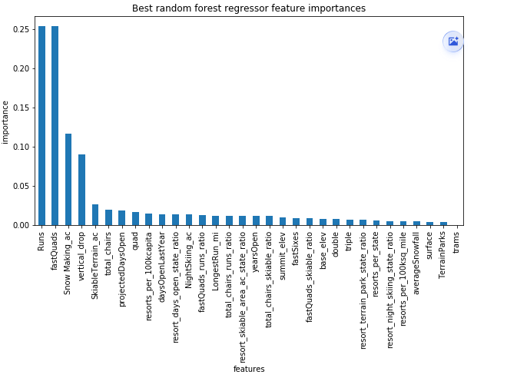
Figure 2: Random Forest Regressor Feature Importances

Pricing Recommendation
- The model suggests that larger resorts with greater vertical drop, more runs, and higher snowmaking coverage can justify higher ticket prices.
- Regional positioning should be used as a supportive context rather than a direct pricing variable, as price variation within states remains large.
- Continuous monitoring of outlier resorts is recommended to maintain realistic pricing expectations.

Conclusion
The Random Forest model accurately captures the key drivers of ticket price variation and provides a solid foundation for future optimization.
Resort size, infrastructure, and snowmaking capacity are the dominant pricing factors, while state and region serve as useful background indicators.

Future Scope of Work
Future work will focus on adding more relevant variables, such as skiable area and snow created, refining outlier detection, and improving feature engineering through ratios like total_chairs_skiable_ratio.
State-level data will be retained as background context but weighted carefully in modeling to avoid overfitting.
Expanding these features will enhance model accuracy and deepen insight for future pricing optimization.

